

***Dism Project Documentation***

**Faculty**: **Shaikh Faizan Hasan**

**Group Members:**

Abdul Rehman ( 1413839 )

M. Huzaifa Khan (1412999 )

Abdul Rehman ( 1413030 )

**ADD CATEGORY:**

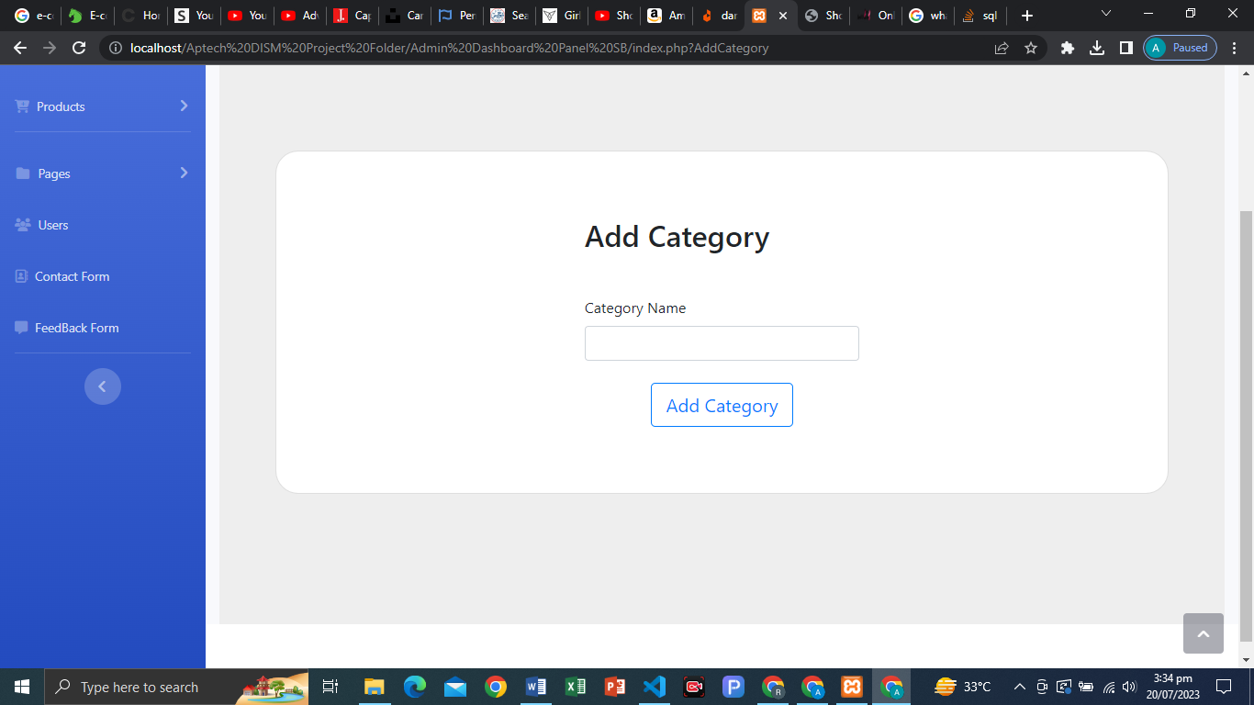

**STRUCTURE CODING:**

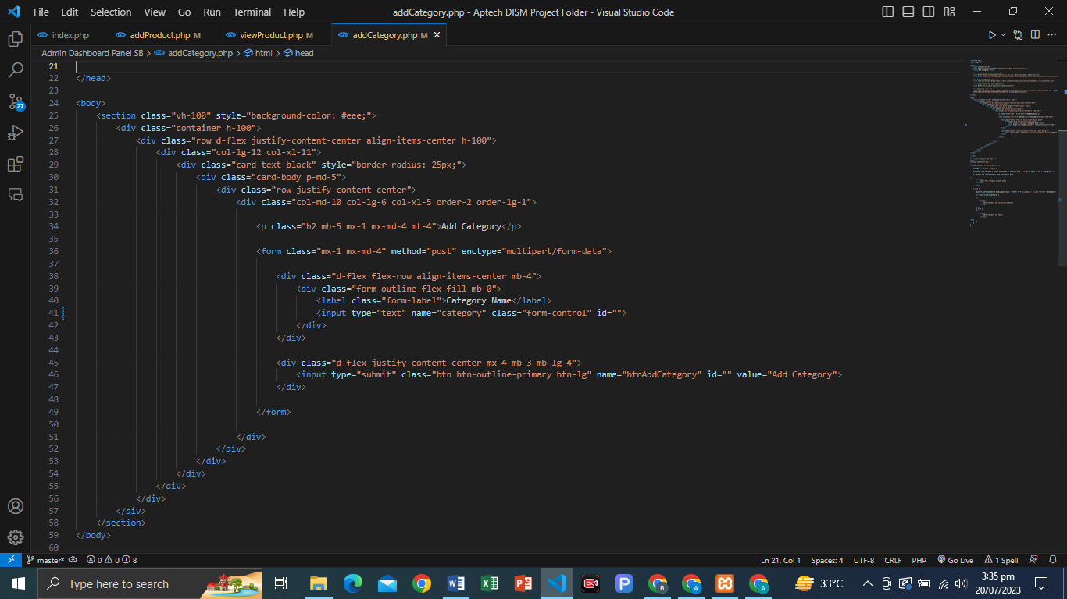

**PHP CODE ADD CATEGORY…!**

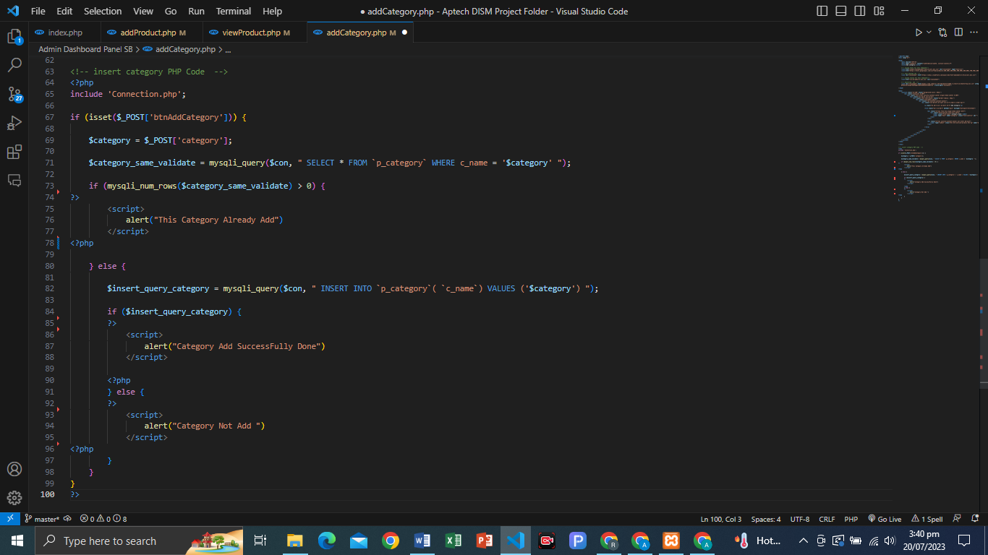

MY SQL CATEGORY TABLE:

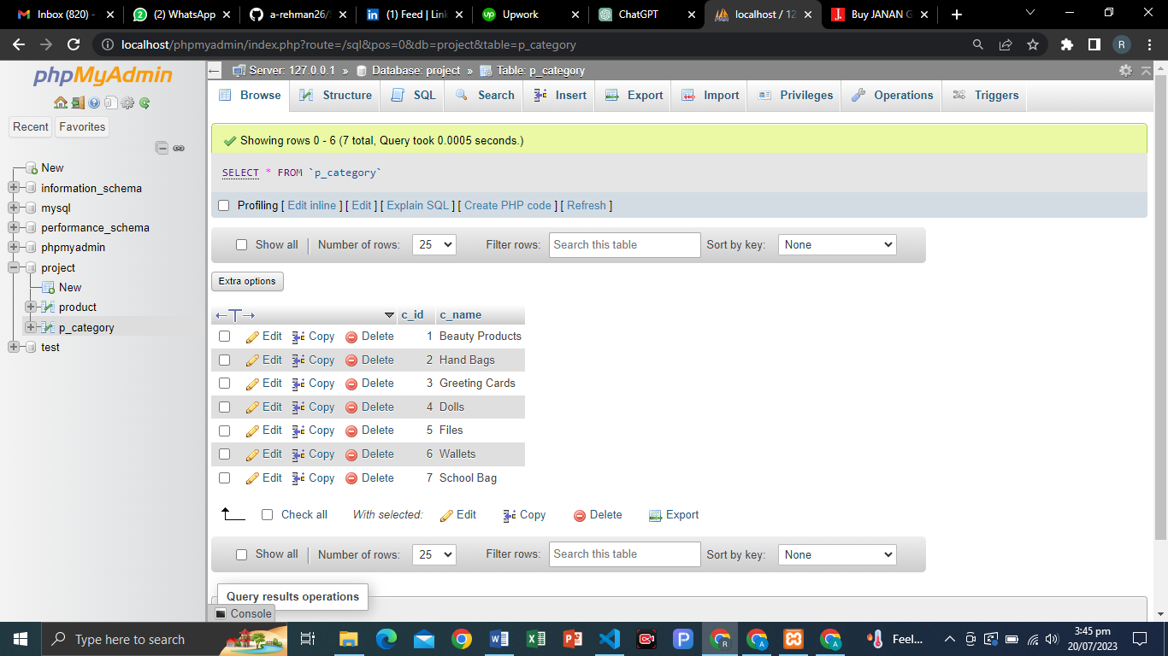

VIEW CATEGORY:

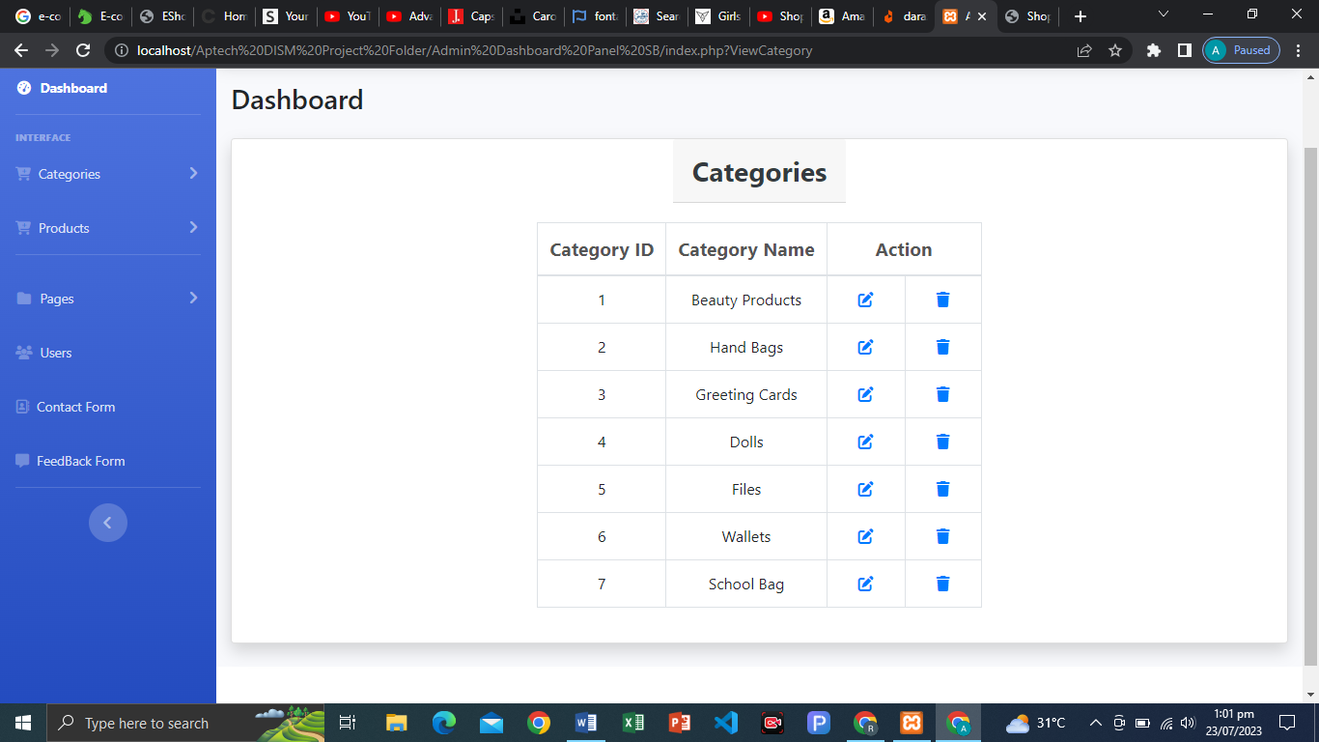

PHP CODE (VIEW CATEGORY):

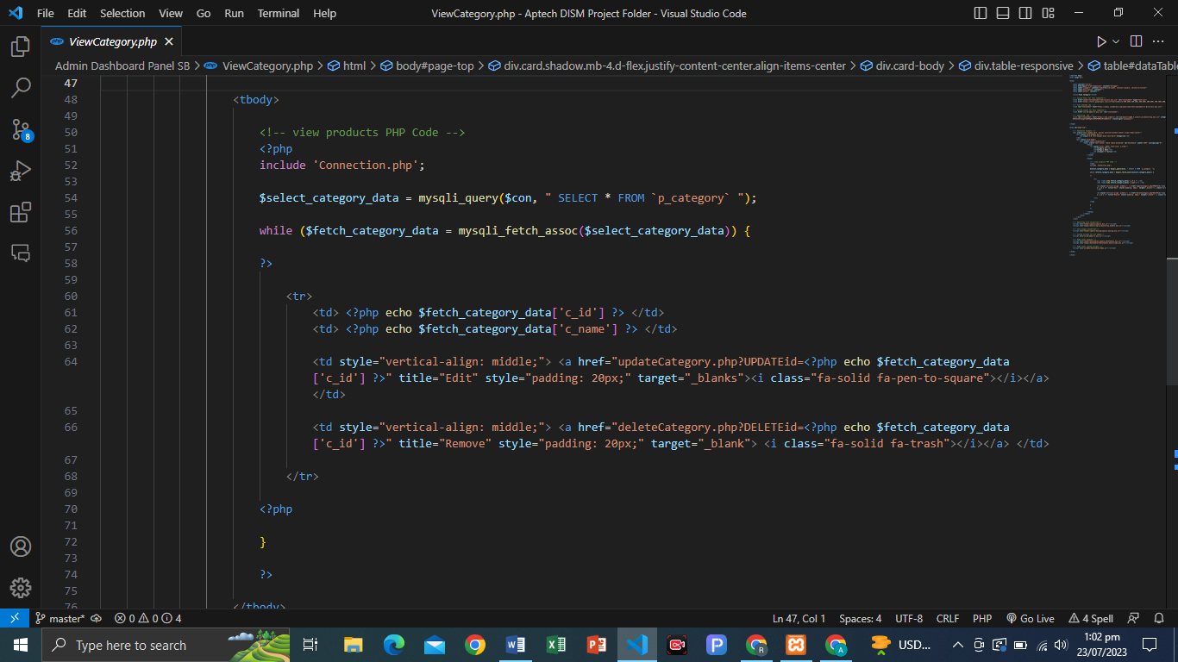

UPDATE CATEGORY:

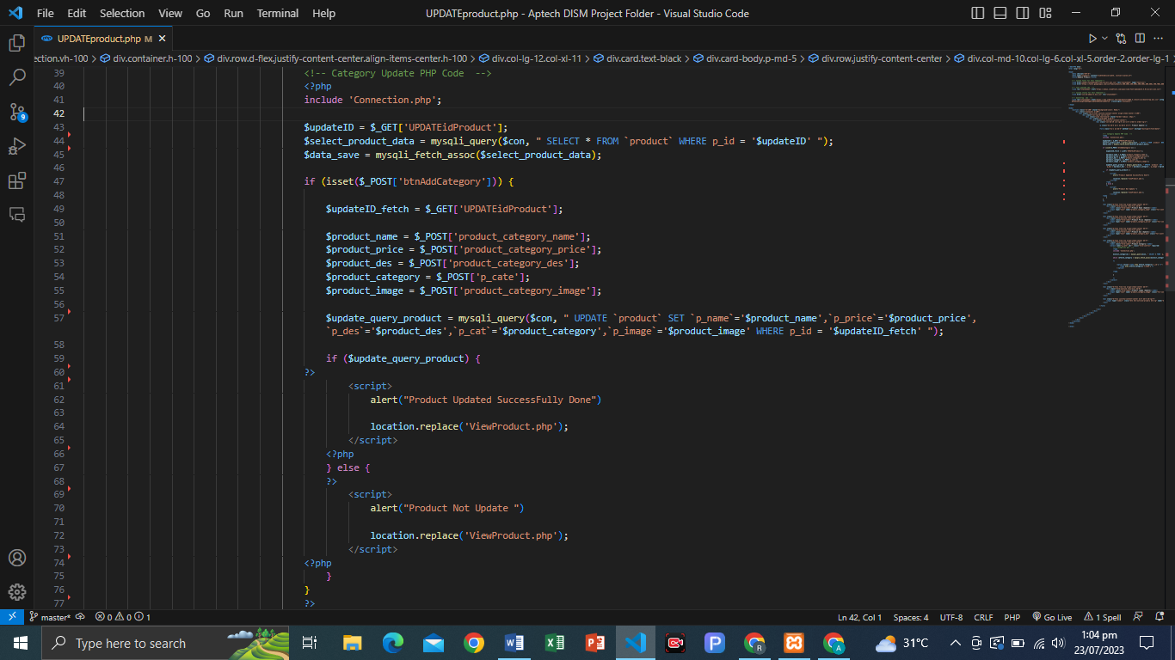

DELETE CATEGORY:

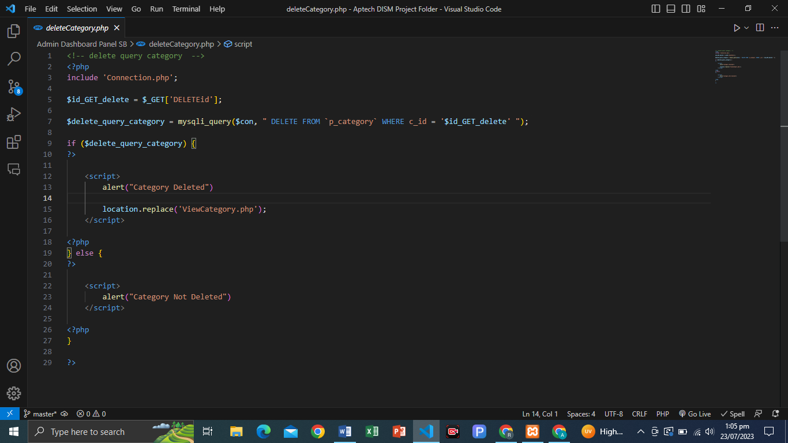

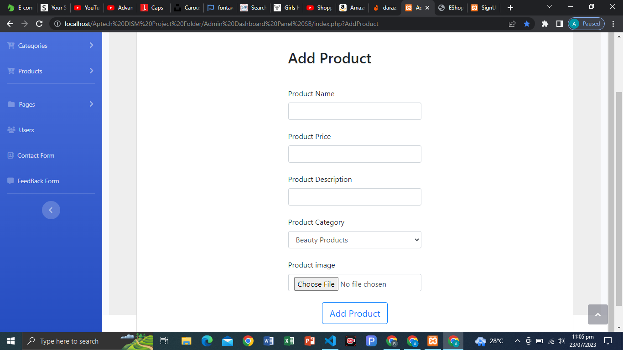ADD PRODUCT:

VIEW CATEGORY:

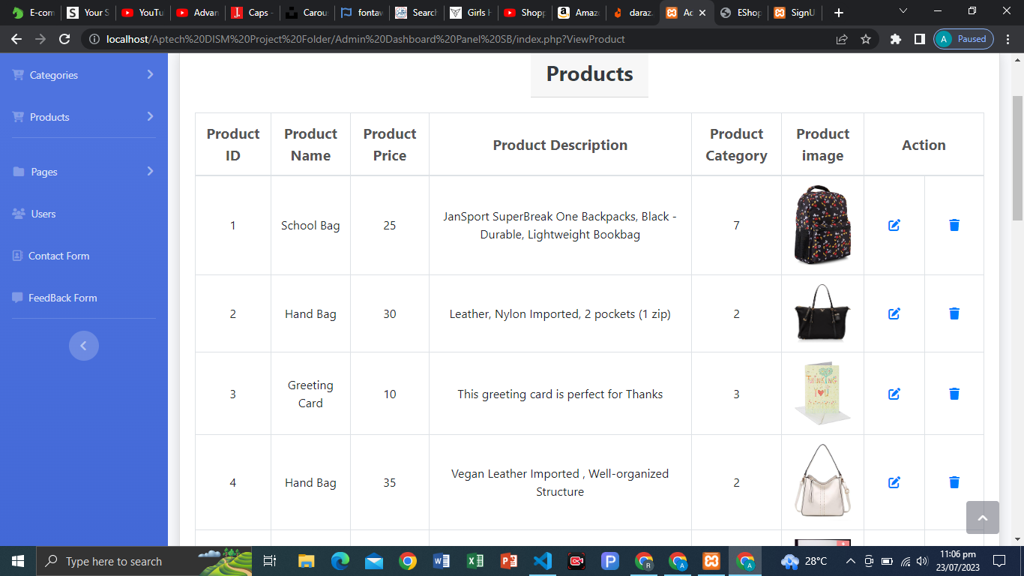

ADD PRODUCT PHP CODE:

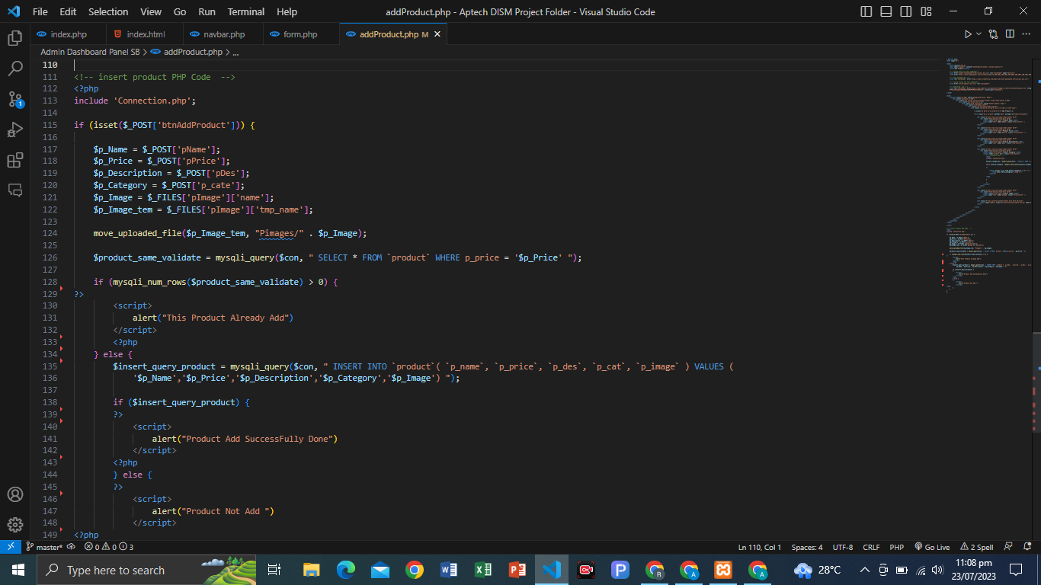

VIEW PRODUCT PHP CODE:

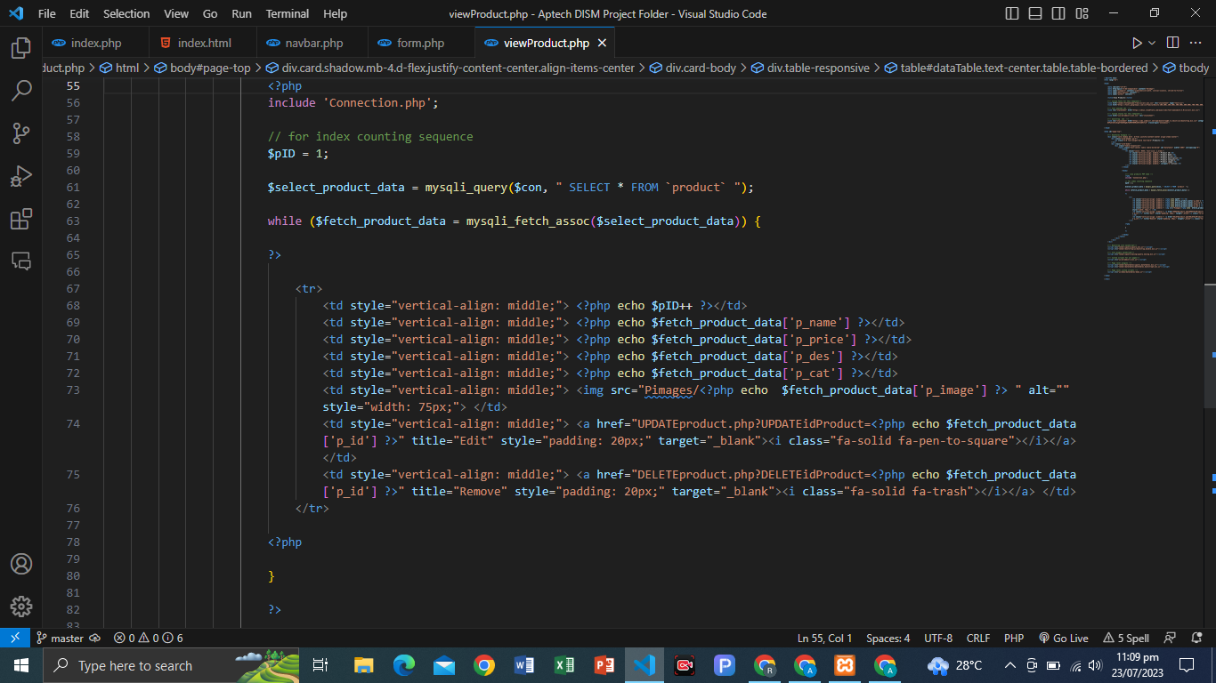

PRODUCT UPDATE PHP CODE:

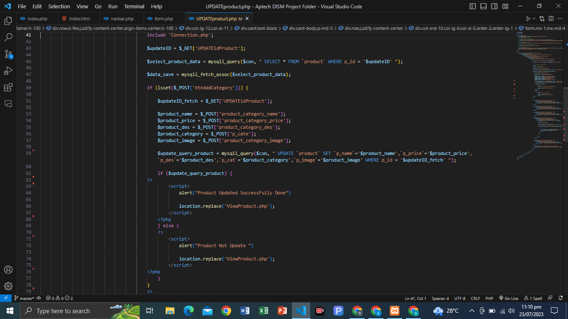

DELETE PRODUCT

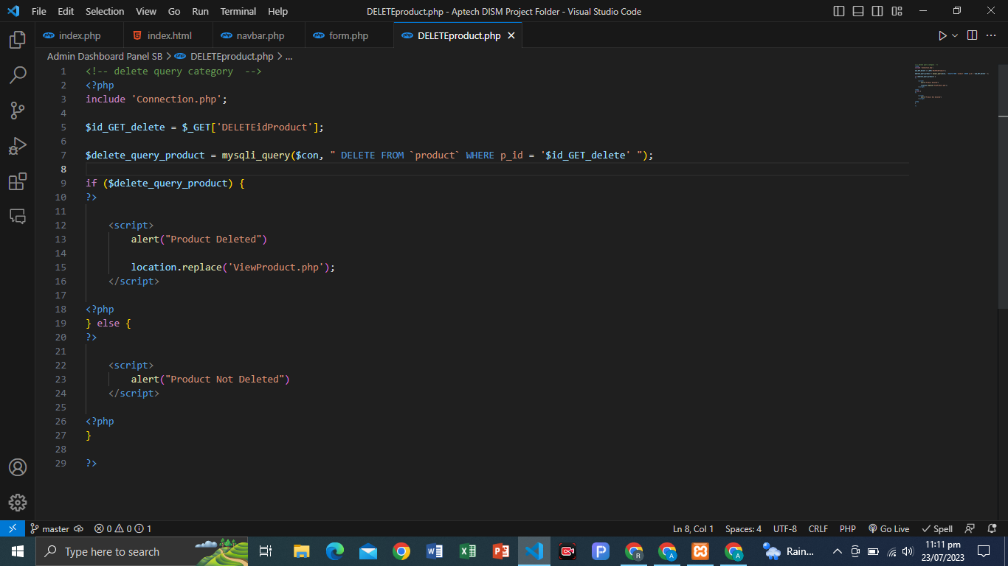

**FETCH CATEGORY IN NAVBAR:**

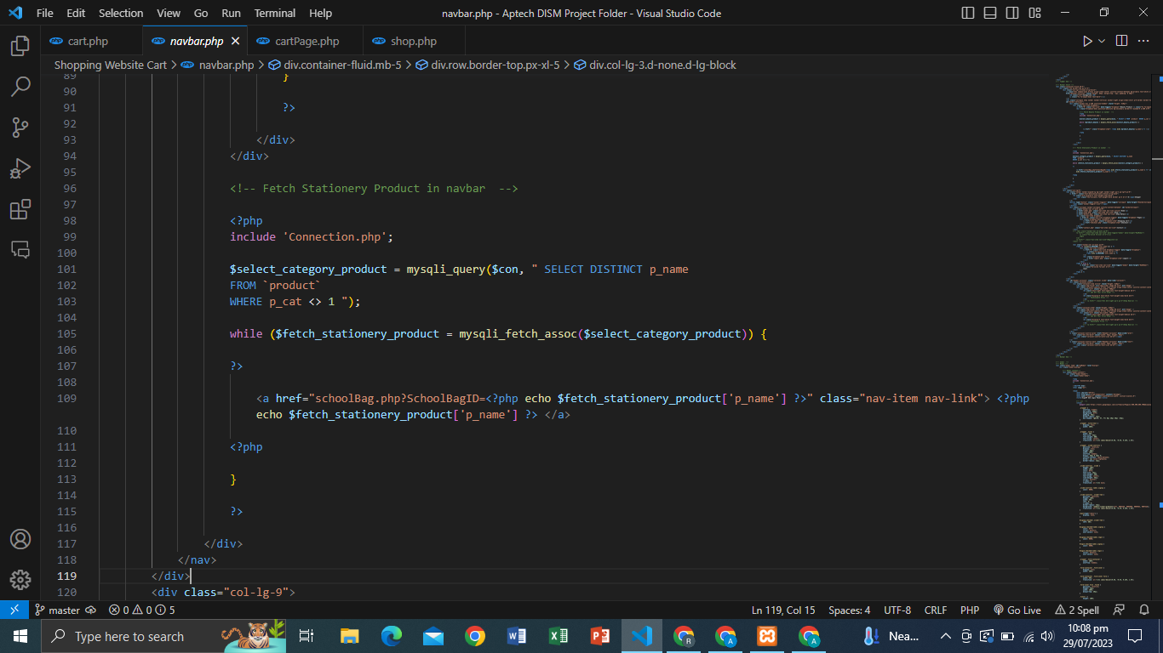

**VIEW PRODUCT DETAIL:**

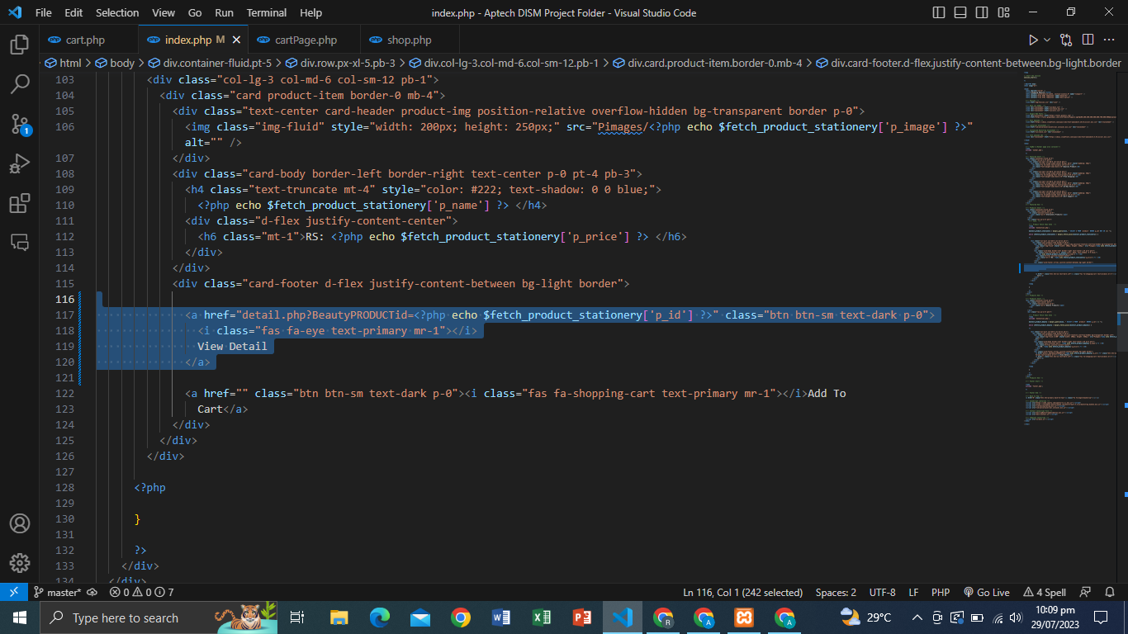

**PRODUCT DETAIL FETCH PAGE:**

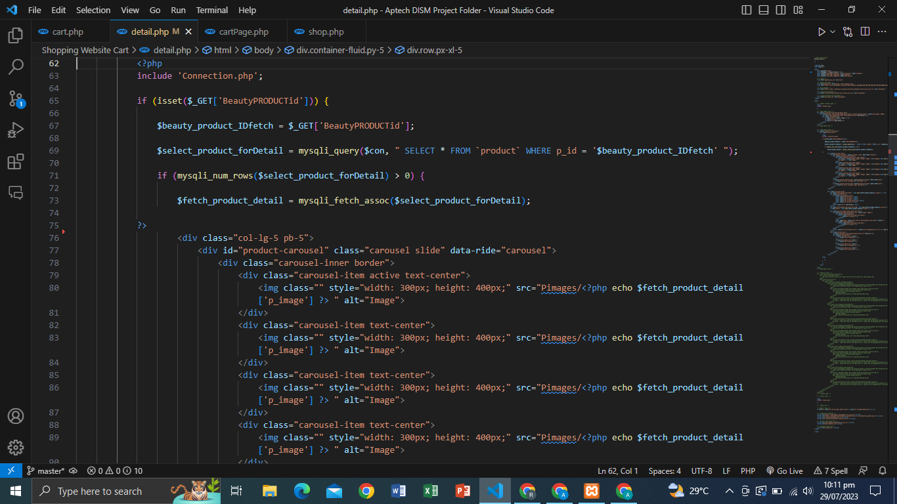

PRODUCT FEEDBACK BUTTON**:**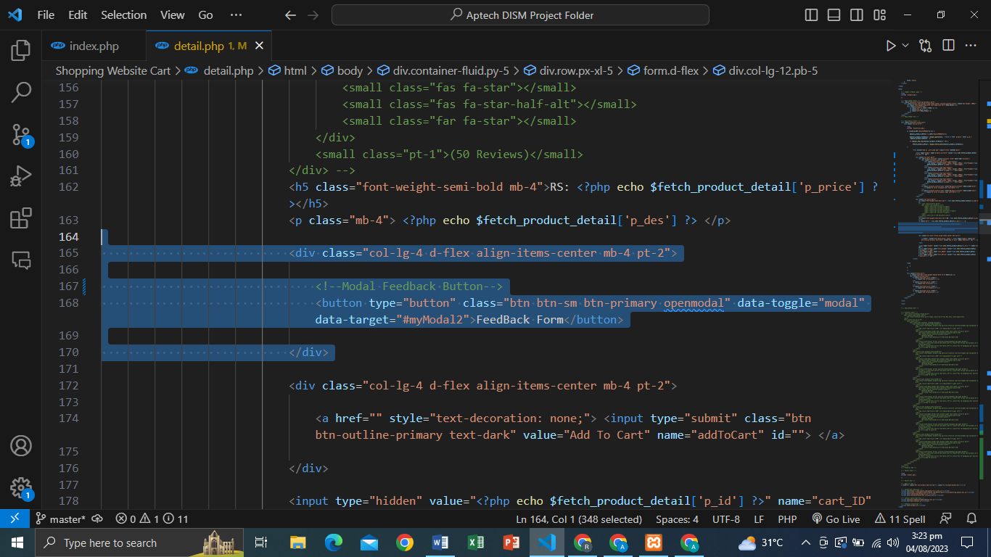

**FEEDBACK FORM:**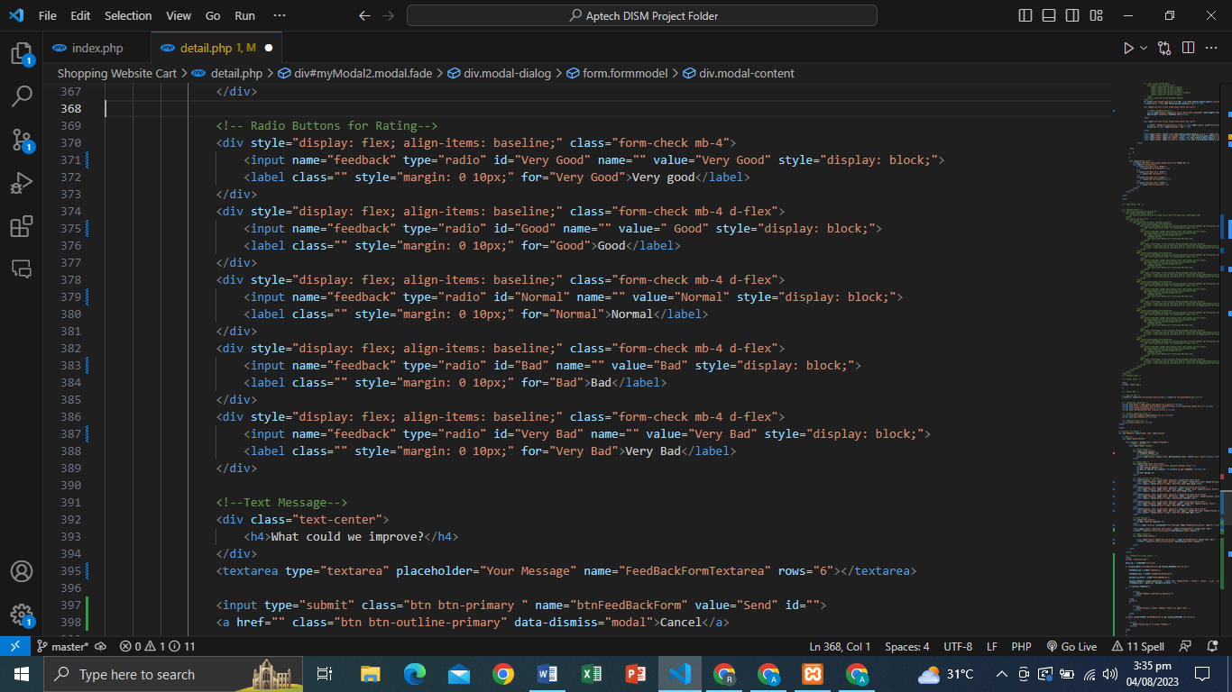

**PHP PRODUCT FEEDBACK FORM DATA INSERT CODE:**

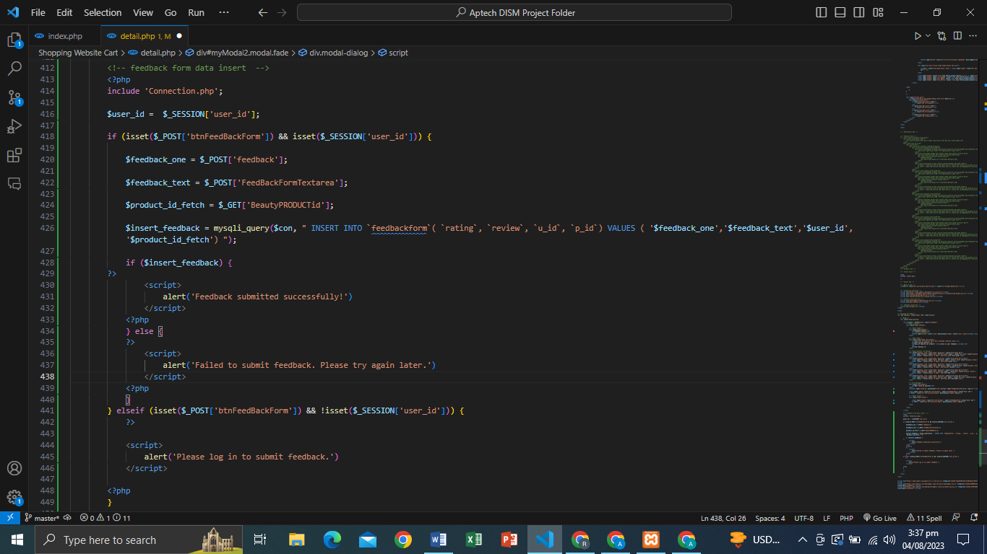

**ADD TO CART**

**ADD TO CART BUTTON:**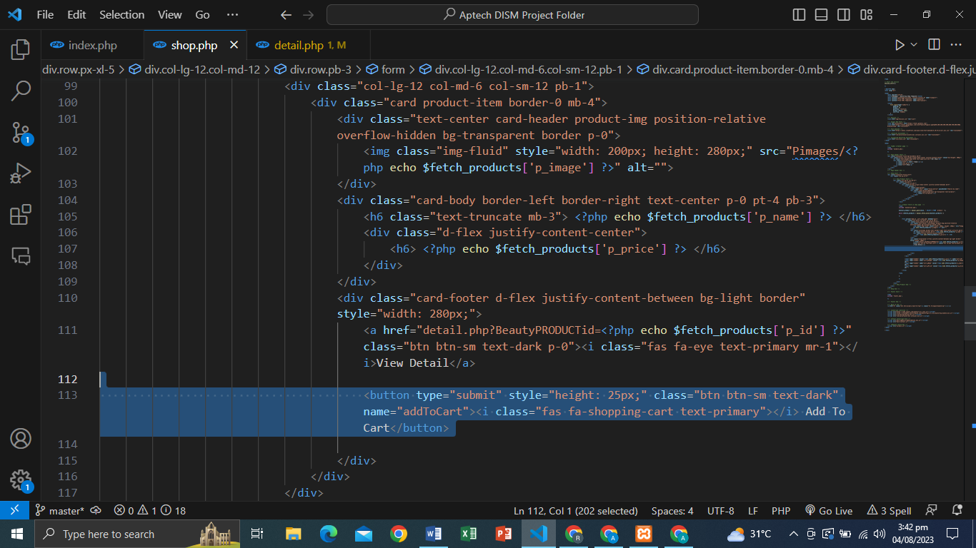

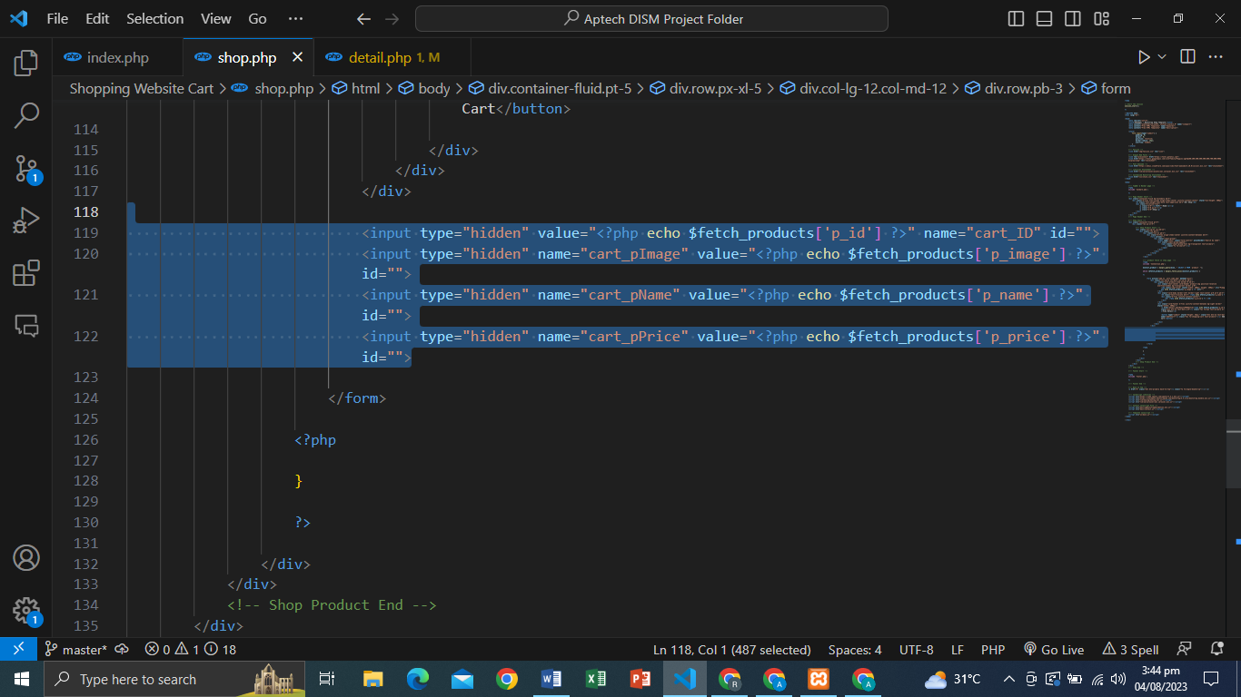**ADD TO CART INPUTS THAT FETCH FOR INSERT CART:**

1. 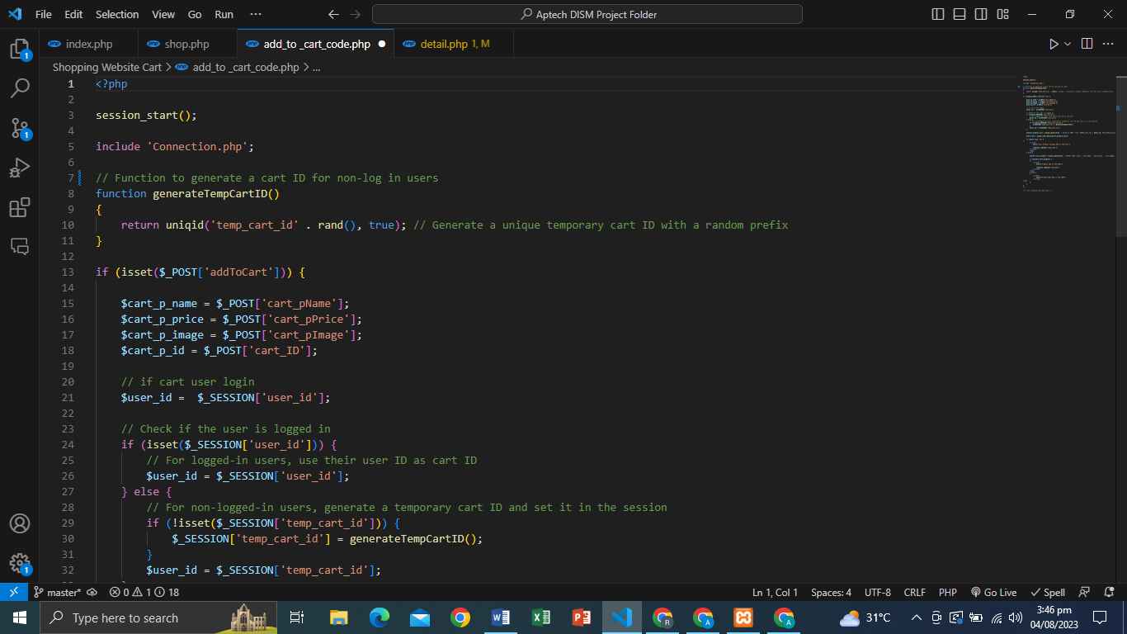**ADD TO CART CODE:**
2. **ADD TO CART CODE:**

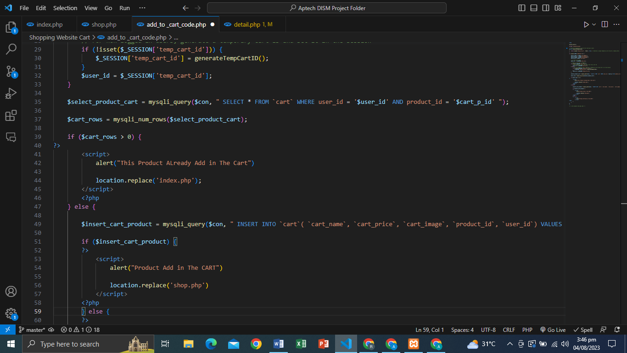

1. **ADD TO CART CODE:**

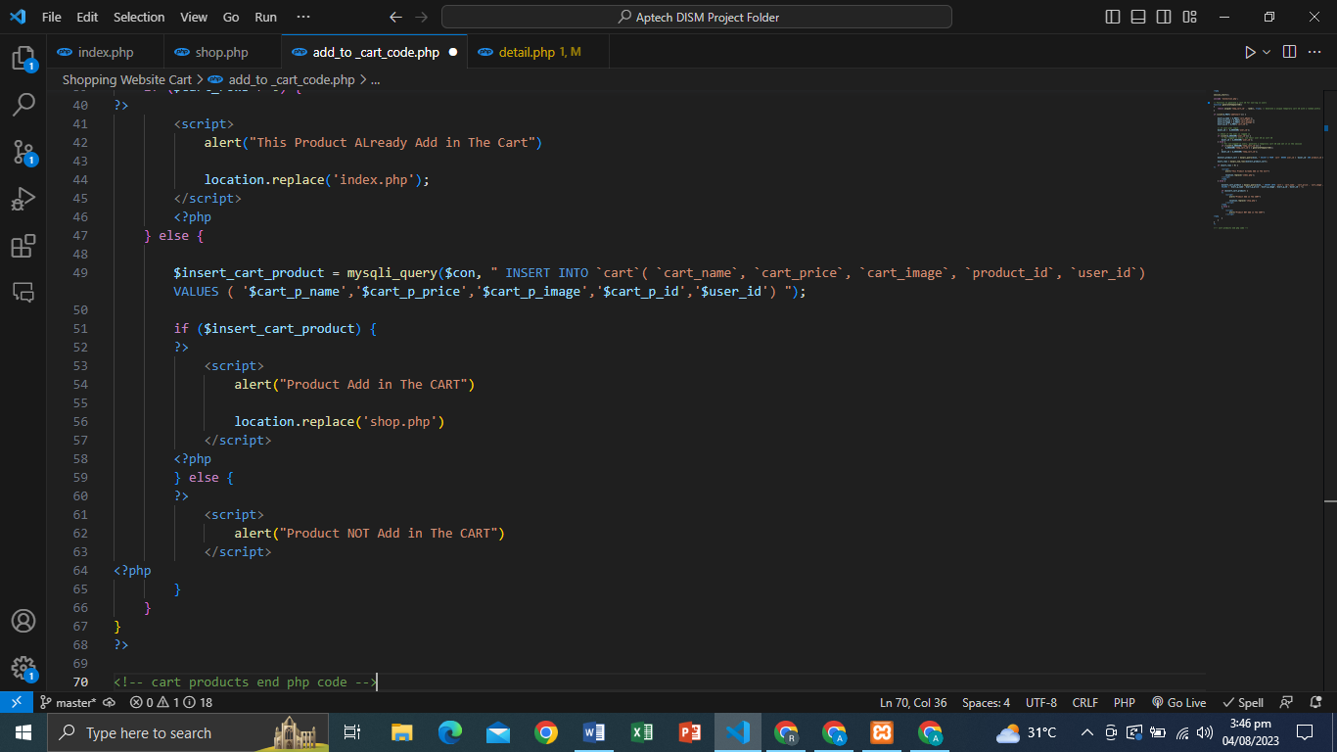

**Contact Form:**

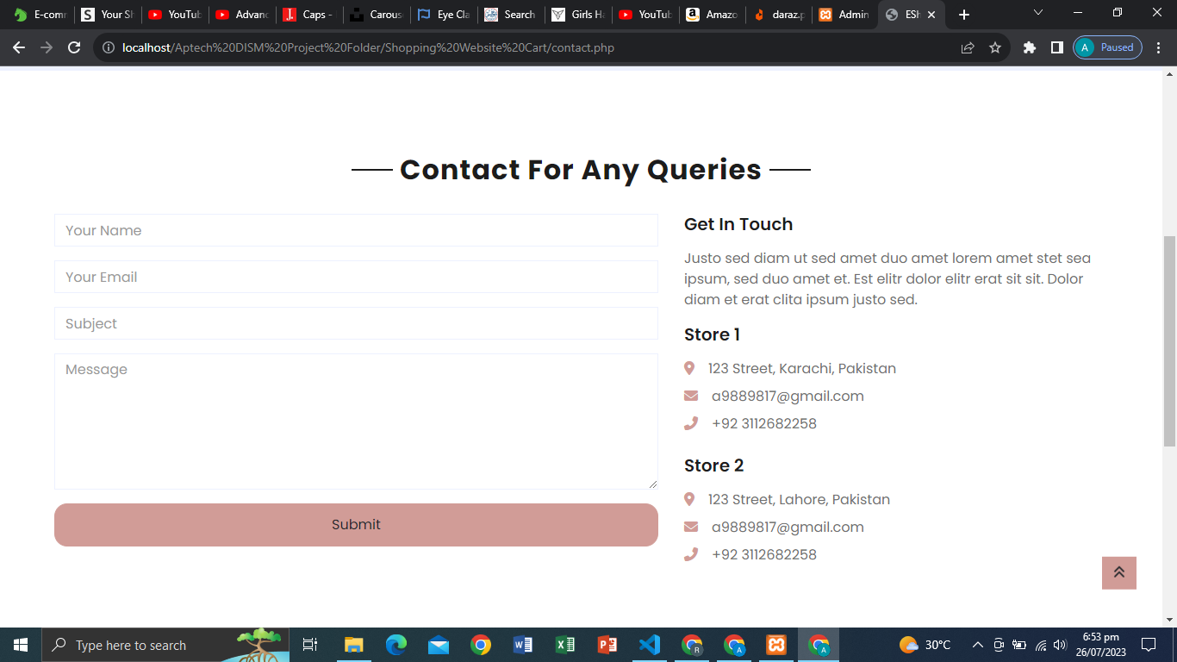

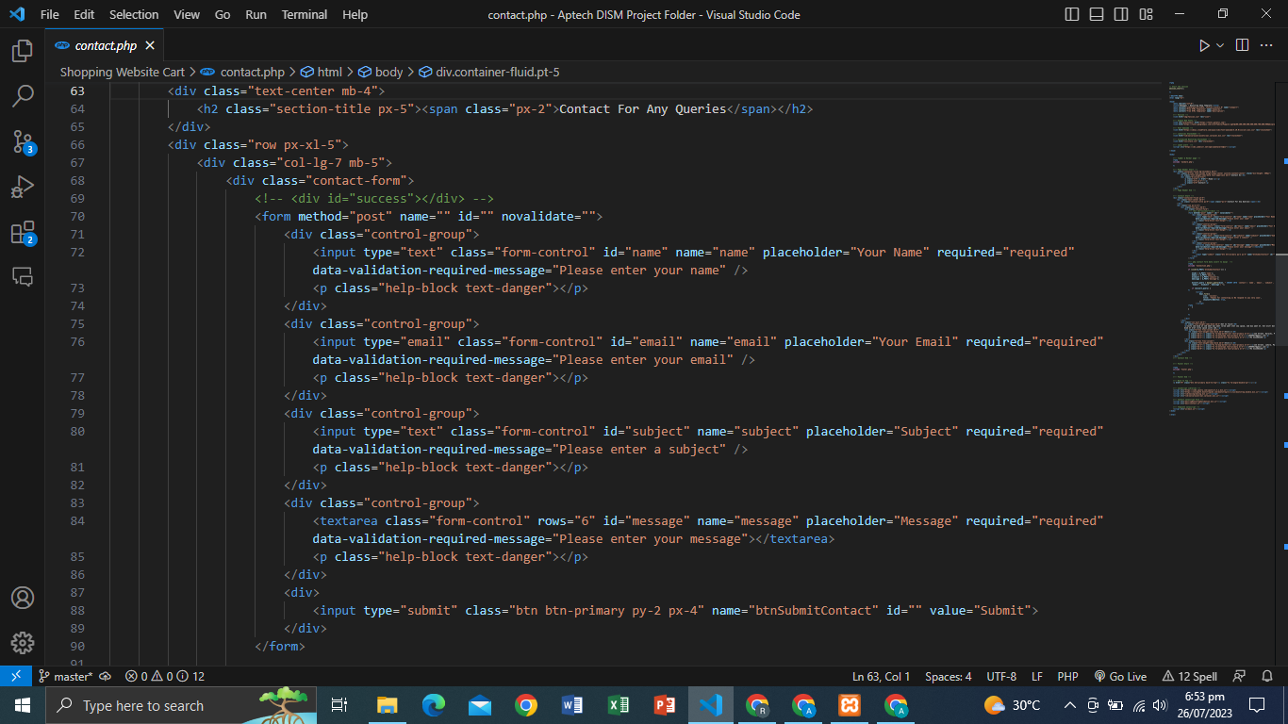**FORM STRUCTURE:**

**PHP DATA INSERT CONTACT FORM:**

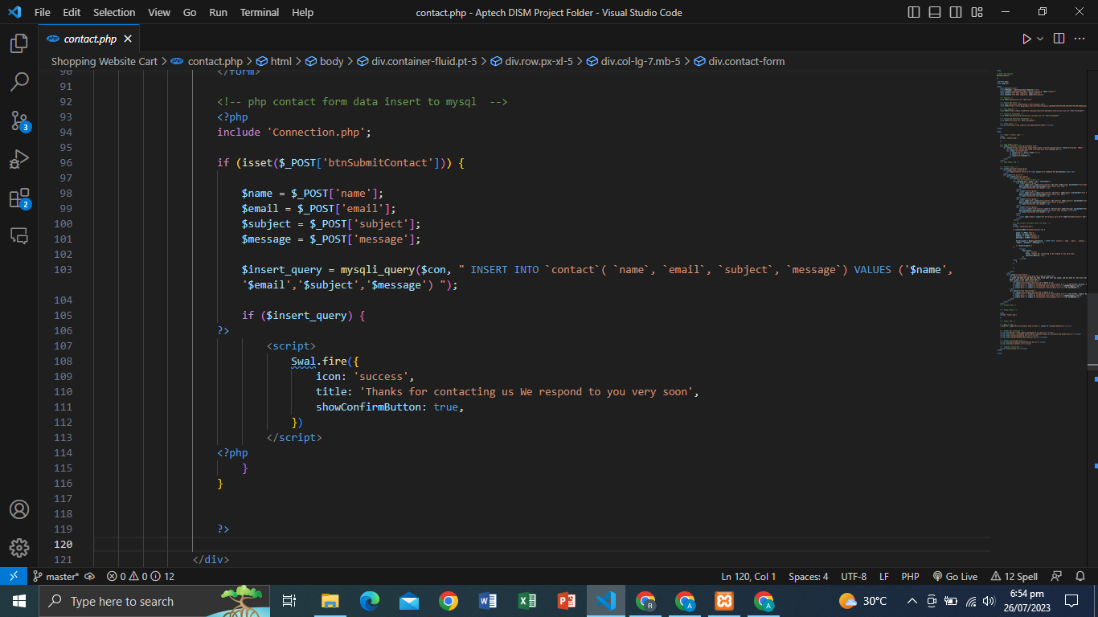

**CONTACT DATA VIEW:**

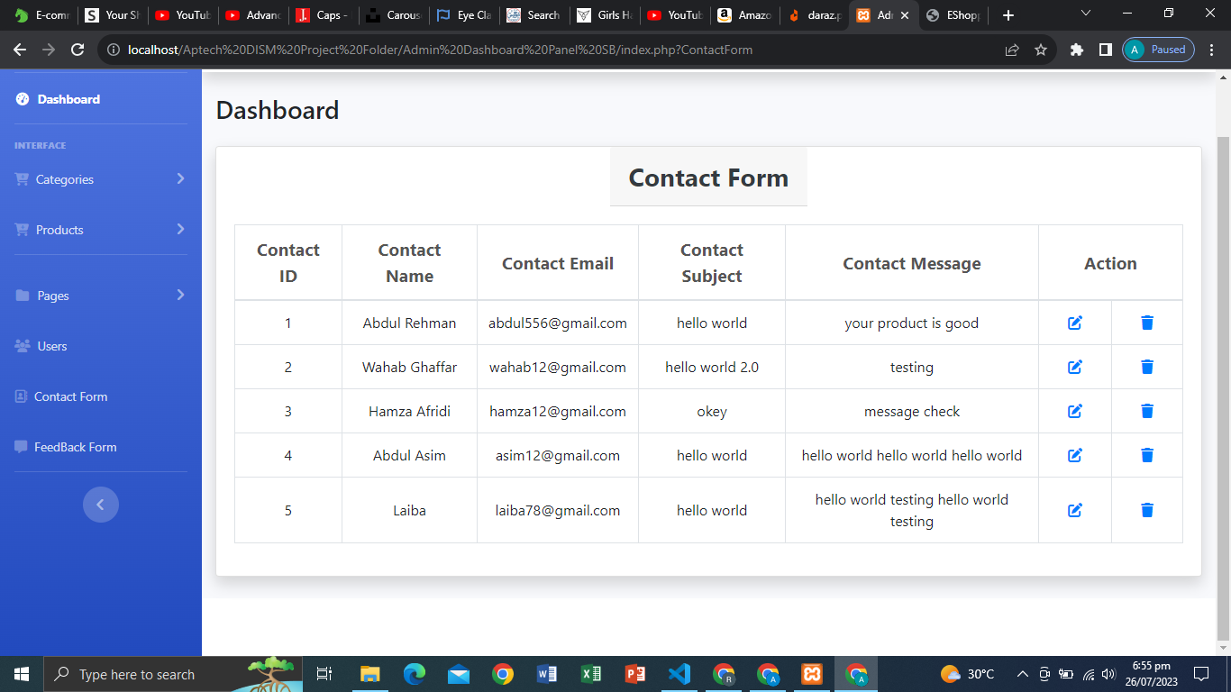

**CONTACT DATA UPDATE CODE:**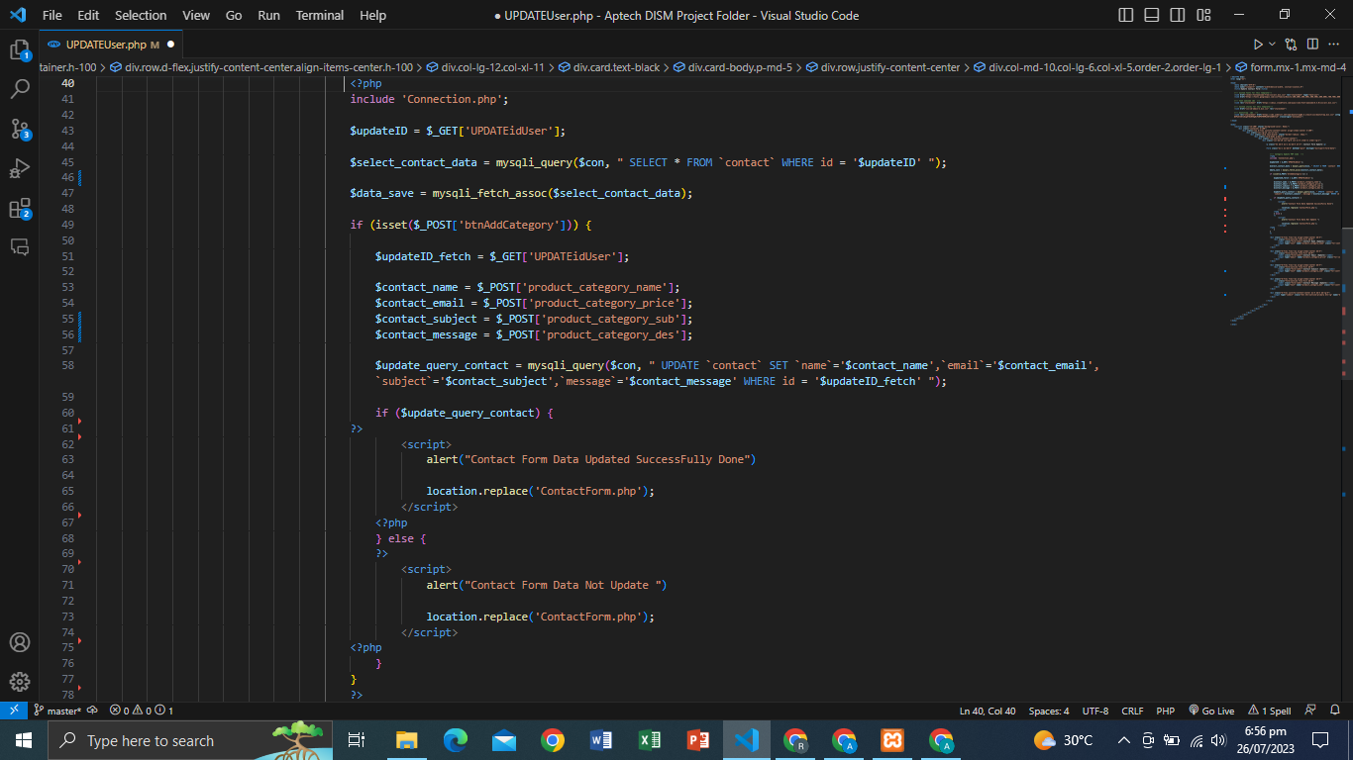

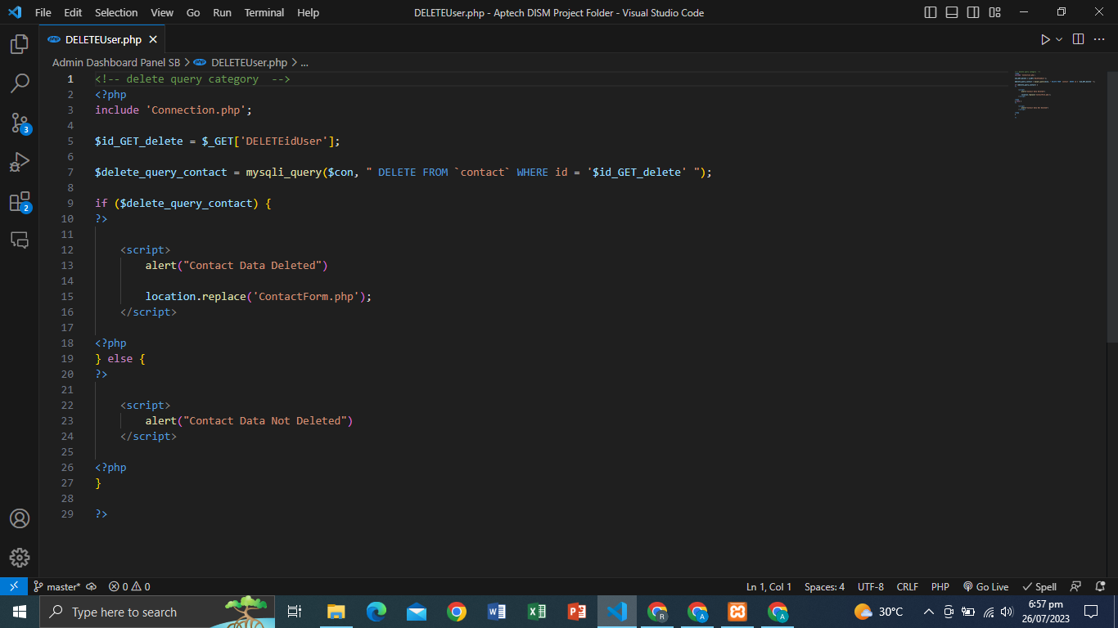**DELETE USER DATA:**

**SIGNUP FORM:**

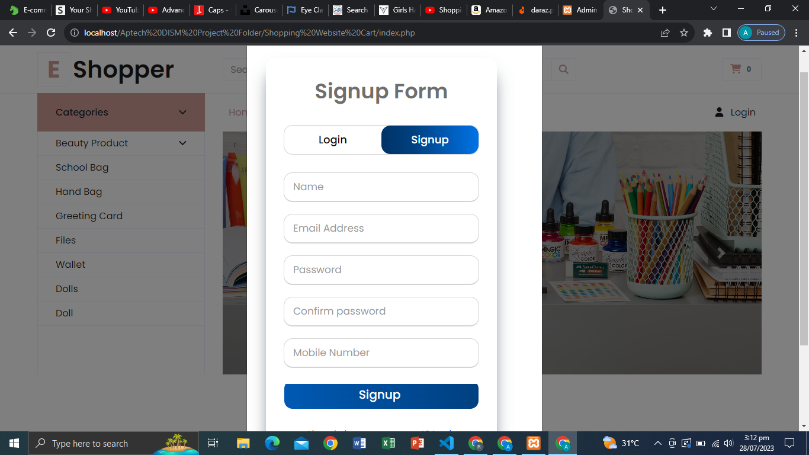

**FORM STRUCTURE:**

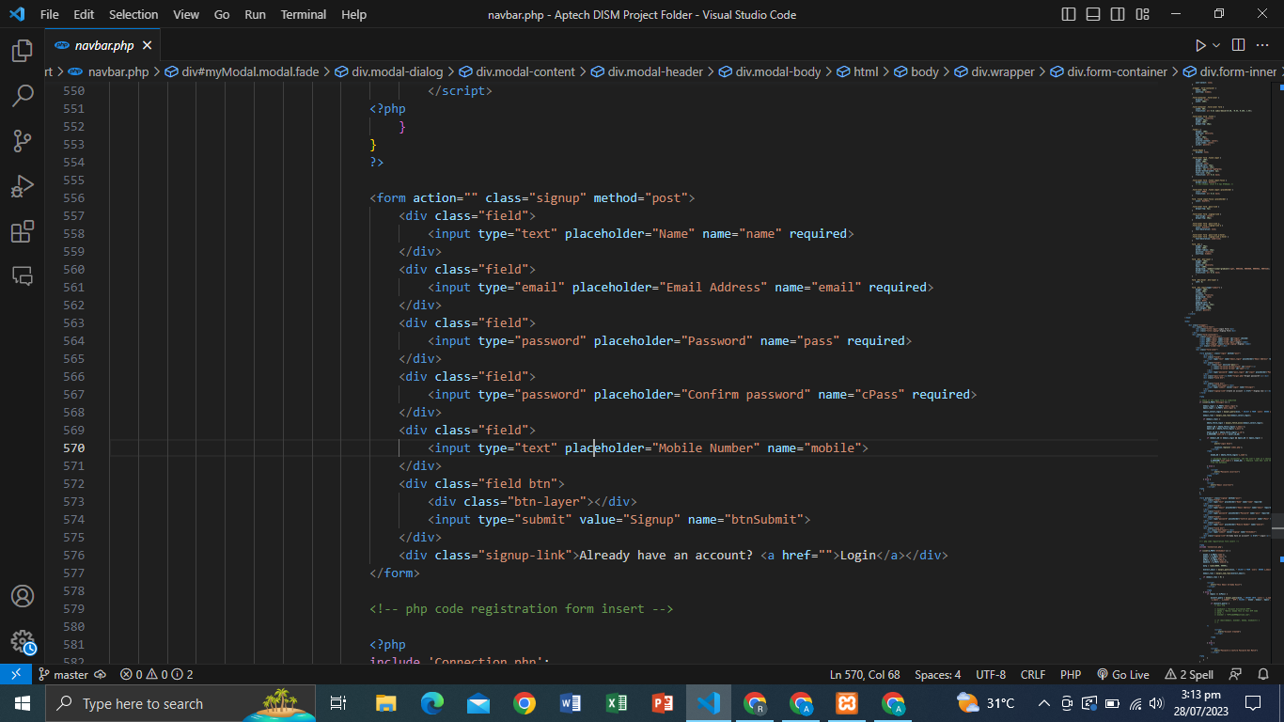

**FORM INSERT DATA PHP CODE:**

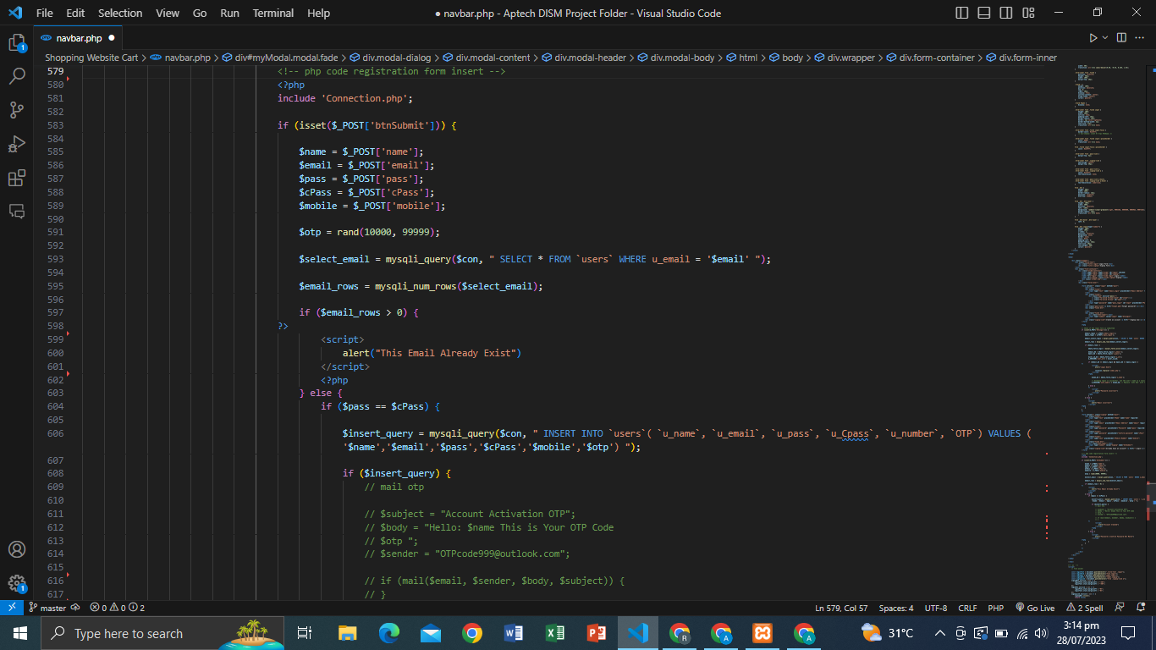

**LOGIN FORM:**

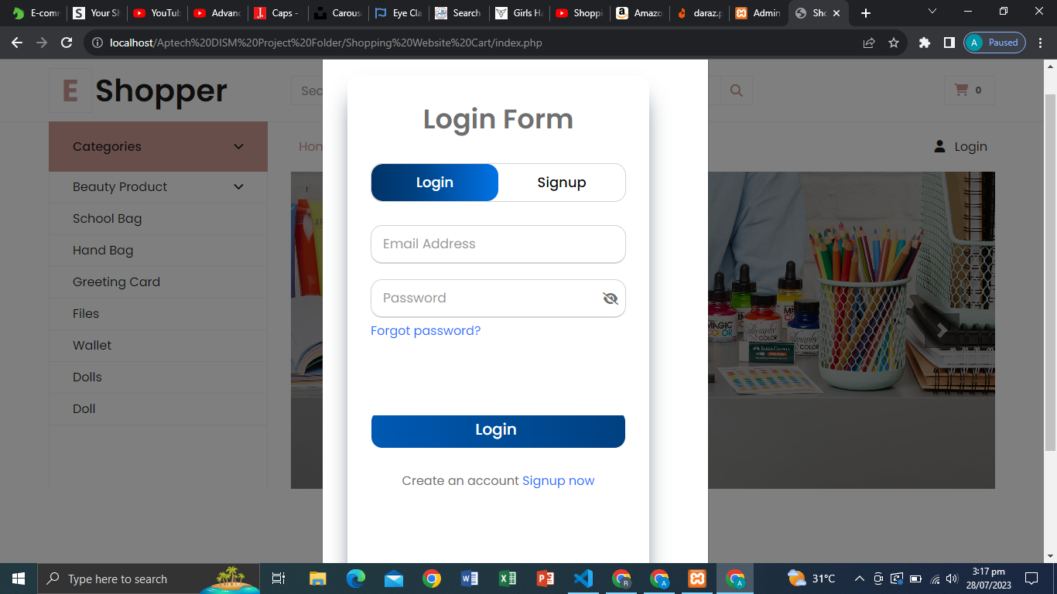

**FORM STRUCTURE LOGIN:**

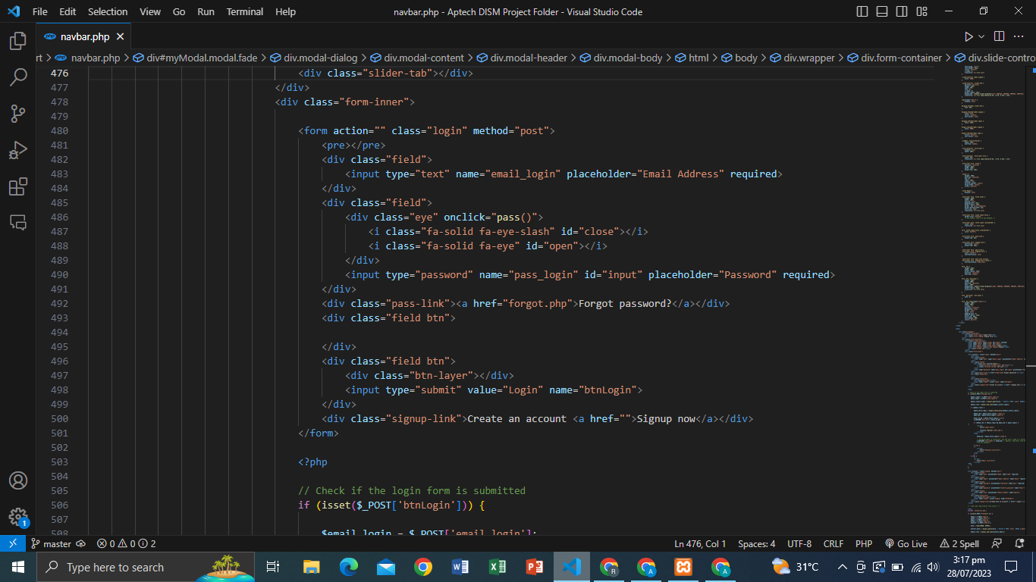

**LOGIN FORM PHP CODE:**

